Joint Price–Volume Anomalies in an Indonesian Mining Equity: Statistical Association and Contextual Evidence from BRMS.JK, 2016–2025

Research Article
Abdillah Arif Nasution¹, Aulia Arif Nasution², Prana Ugiana Gio³
1 Department of Accounting, Universitas Sumatera Utara, Medan 20155, Indonesia
2 Fakultas Vokasi, Universitas Sumatera Utara, Medan 20155, Indonesia
3 Department of Mathematics, Universitas Sumatera Utara, Medan 20155, Indonesia
Emails: Abdillah Arif Nasution: badinst@usu.ac.id; Aulia Arif Nasution: aulianasution@usu.ac.id; Prana Ugiana Gio: prana@usu.ac.id
Corresponding author: Abdillah Arif Nasution, badinst@usu.ac.id

Abstract
This study examines extreme price and trading-volume behavior in PT Bumi Resources Minerals Tbk (BRMS) during 2016–2025 using an integrated descriptive-associational and contextual framework. Daily observations from Yahoo Finance were screened and chronologically aligned, yielding 2,390 retained trading observations and 2,389 valid paired observations. Price anomalies were identified from the upper empirical tail of absolute daily returns, while volume anomalies were classified from the lower and upper tails of signed daily volume changes. Twenty-three simultaneous price–volume anomalies were observed, compared with approximately 12.06 expected under statistical independence; 20 combined a sharp price increase with an abnormally large volume increase. Pearson’s chi-square test indicated significant dependence (χ² = 11.6304, p = 0.0006), and the sample odds ratio was 2.24 (95% CI: 1.39–3.61). Phi/Cramér’s V was approximately 0.070, indicating limited association magnitude. Documentary validation of 11 prespecified events classified 2 as High, 4 as Moderate, and 5 as Not Externally Validated. The findings distinguish aggregate statistical dependence from event-specific documentary correspondence. Joint price–volume anomalies may support transparent market screening and structured follow-up analysis, but they should not be interpreted as standalone evidence of prediction, causality, or market misconduct in practice.
Keywords: price–volume association; extreme returns; trading volume; market anomaly; mining equity; Indonesia

1. Introduction
Stock prices and trading volume provide complementary views of market activity: prices summarize valuation changes, whereas volume records the intensity of trading. Their joint behavior has therefore been central to empirical finance. Karpoff (1987), Gallant et al. (1992), and Campbell et al. (1993) document systematic price-volume relationships, but those relationships do not imply a single or stable causal mechanism. For the present study, joint analysis is used to identify empirical dependence and unusual co-occurrences while maintaining a strict distinction between statistical association and causal attribution.
A tail-focused approach is particularly useful when average relations may conceal infrequent but economically visible observations. The present design therefore treats the price and volume dimensions in parallel at the classification stage while recognizing that their empirical distributions require different directional rules. Price extremes are identified from absolute return magnitude and then restored to their signed direction, whereas volume extremes are identified from the signed distribution because sharp contractions and expansions are substantively different trading states. This design choice allows the analysis to preserve direction without assuming that positive and negative tails have identical economic meaning.
Return-volume dependence can vary across market states and distributional regions. Ciner (2015) reports time-varying return-volume relationships in precious-metals mining stocks, while Lin and González-Rivera (2019) show that extreme returns and trading intensity can display dynamics that differ from those near the center of the distribution. This heterogeneity motivates a tail-oriented design in which unusually large price and volume observations are identified explicitly rather than inferred from unconditional averages.
Extreme observations are a recognized object of market research. Gervais et al. (2001) examine unusual trading-volume states, and Larson and Madura (2003) distinguish extreme one-day returns associated with identifiable public information from events lacking a readily documented catalyst. Because the literature uses different definitions of 'extreme', the present study does not treat any percentile as a universal market standard. Instead, empirical percentiles provide transparent, sample-specific operational boundaries for identifying unusual BRMS observations.
Quantitative co-occurrence alone does not reveal the public-information environment surrounding an event. Research on attention and information dissemination shows that news, media exposure, extreme returns, and unusual volume can be related to trading behavior (Barber & Odean, 2008; Engelberg & Parsons, 2011; Peress, 2014). Those studies motivate a separate documentary layer here, but their causal results are not transferred to this security-level design. Public information is used only to assess temporal and substantive correspondence with selected anomalies.
Mining equities offer a relevant setting because equity-market, operational, financing, and commodity-related conditions may interact without making the stock equivalent to the underlying commodity. Baur et al. (2021), Ciner (2015), and Qin et al. (2023) document distinctive risk and tail behavior in mining-related equities. BRMS is therefore examined as a resource-sector security with security-specific price-volume dynamics; the study does not estimate structural commodity exposure or use BRMS as a proxy for gold-price effects.
The Indonesian mining-equity literature reviewed for this study includes macro-financial, commodity, forecasting, portfolio, and risk applications (Ahadiat et al., 2023; Endri et al., 2021; Pungkasanti et al., 2026; Putra & Robiyanto, 2019). Comparatively less evidence was located on a framework that combines long-horizon price-volume characterization, empirical tail classification, contemporaneous joint-anomaly mapping, categorical association testing, and structured documentary validation. This observation is limited to the reviewed literature and is not a claim that Indonesian mining research is methodologically homogeneous.
The emerging-market setting also matters for interpretation. Evidence from one Indonesian issuer cannot establish a market-wide regularity, but it can reveal how established price-volume concepts behave in a security with distinctive trading history and episodic changes in activity. By focusing on a long daily window rather than a short event interval, the study first characterizes the underlying distribution of BRMS observations and then identifies unusual co-occurrences relative to that same empirical history. The contextual stage is deliberately secondary to the statistical classification, which reduces the risk that event narratives determine which observations are labeled anomalous.
At the issuer level, BRMS has been examined in other academic contexts, so it should not be described as an unstudied company. Under the search strategy used for this study, however, no directly comparable peer-reviewed BRMS paper was identified that integrates the full sequence of tail identification, same-observation price-volume mapping, association magnitude, and prespecified contextual validation. The contribution is therefore analytical integration and BRMS-specific emerging-market evidence rather than methodological invention or a 'first-ever' claim.
This contribution is therefore narrower than proposing a new anomaly test and broader than presenting a simple descriptive chronology. The paper links four analytical questions that are often separated: what constitutes an extreme observation within the sample; whether price and volume extremes occur on the same day; whether their binary statuses depart from independence; and whether selected joint events can be matched to credible public information under a fixed search protocol. The resulting evidence is intended to be reproducible and auditable while remaining explicit about the limits of a single-security observational design.
Accordingly, the study examines BRMS daily price and trading-volume dynamics from 2016 to 2025 with four connected objectives: to characterize long-horizon price and trading activity; identify empirical price and signed-volume tail events; evaluate their contemporaneous co-occurrence and statistical association; and contextualize a prespecified subset of joint anomalies using credible public information. The design deliberately separates descriptive dynamics, tail classification, statistical dependence, and documentary correspondence so that neither association nor contextual evidence is interpreted as causal transmission.

2. Materials and Methods

2.1. Research Design and Analytical Framework
This study employed a longitudinal, single-security, descriptive-associational design for PT Bumi Resources Minerals Tbk (BRMS.JK), 2016–2025. The workflow moved sequentially from data screening and chronological alignment to construction of price and volume variables, empirical tail classification, same-observation joint-anomaly mapping, 2 × 2 association testing, and documentary validation of a prespecified event subset. Joint price-volume analysis is consistent with established empirical finance (Campbell et al., 1993; Gallant et al., 1992; Karpoff, 1987), but the present design does not estimate causal effects, lead-lag transmission, or expected-return models.

2.2. Data Source, Security, and Observation Period
The empirical analysis focused on PT Bumi Resources Minerals Tbk (BRMS.JK). Daily observations were obtained from the Yahoo Finance historical-data interface (Yahoo Finance, n.d.), which is treated as a secondary data-access source rather than the official Indonesia Stock Exchange database. The source fields included Date, Open, High, Low, Close, Adjusted Close, and Volume; calculations used the Close field and therefore represent simple close-to-close price returns rather than an explicit total-return measure. The retained observation period was 4 January 2016–30 December 2025, yielding 2,390 trading observations and 2,389 valid lagged pairs. The archived analytical record shows processing on 5 August 2026 at 07:03:57; software package versions were not reconstructed retrospectively because they were not preserved in the metadata.
The source snapshot was preserved as an MHTML copy of the Yahoo Finance historical-data page, providing a fixed archival input for the analysis rather than relying on a subsequently changing web view. The analytical workflow separated the source table, retained clean observations, excluded-row audit, calculated variables, metadata, and methodological settings. Missing or invalid volume observations were preserved as missing in the audit and were never converted to zero, which is important because zero would represent a substantive trading value rather than an unavailable observation.

2.3. Data Preparation and Trading-Day Alignment
Observations were screened for valid dates, positive numerical market fields, duplicate or non-trading records, and logical OHLC consistency. Missing or invalid Volume values were never replaced with zero; such rows were retained in the audit trail but excluded before lagged price and volume variables were constructed. Retained observations were sorted from oldest to newest before applying a one-observation lag, so t−1 denotes the immediately preceding retained trading observation rather than the preceding calendar day. Percentage volume changes were calculated only when the preceding retained volume was valid and non-zero. This convention allows lags to cross weekends, holidays, and year boundaries without creating artificial non-trading observations.
The retained series also enforced logical OHLC relationships before lag construction. One source row with an inconsistent OHLC range was excluded, while rows with missing or invalid trading volume were retained in the audit but not in the analytical sequence. Constructing lags only after these exclusions means that both price and volume changes refer to the immediately preceding retained observation. This implementation detail is important for reproducibility because using the previous raw row instead would create a different return and volume-change sequence whenever an excluded observation occurred.

2.4. Construction of Price and Return Variables
Let Pₜ denote the BRMS closing price at retained trading observation t and Pₜ₋₁ the closing price at the immediately preceding retained trading observation.
The Daily Closing Price Change was calculated as:
ΔPₜ = Pₜ − Pₜ₋₁ | (1)

Daily price direction was classified as Increase when ΔPₜ > 0, Decrease when ΔPₜ < 0, and Unchanged when ΔPₜ = 0.
The Daily Stock Return (%) was calculated as a simple close-to-close percentage price return:
Rₜ = [(Pₜ − Pₜ₋₁) / Pₜ₋₁] × 100 | (2)

where Rₜ is the percentage close-to-close return at observation t (Campbell et al., 1997).
To characterize the magnitude of a daily price movement independently of its direction, the Absolute Daily Stock Return (%) was defined as:
ARₜ = |Rₜ| | (3)

The signed return and its absolute magnitude were retained separately so that tail magnitude and direction could be distinguished (Ding et al., 1993).
Annual closing-price performance compared the first and final retained closing prices in each calendar year:
APCᵧ = [(Pᵧ,T − Pᵧ,₁) / Pᵧ,₁] × 100 | (4)

Thus, annual performance is a first-to-final retained closing-price comparison rather than a within-year minimum-to-maximum range.

2.5. Percentile-Based Price-Anomaly Identification
Price anomalies were identified from the distribution of Absolute Daily Stock Return (%) across the 2,389 valid paired observations. Empirical percentiles were computed by linear interpolation equivalent to the Type 7 sample-quantile convention in the Hyndman–Fan taxonomy (Hyndman & Fan, 1996). The 95th percentile was used as a study-specific upper-tail boundary; it is an operational rule for this sample, not a universal financial-market cutoff.
The resulting price threshold was 8.09529381479488%, reported as 8.0953% in the manuscript. A return above this boundary was classified as a Sharp Price Increase, a return below its negative counterpart as a Sharp Price Decrease, and all other observations as normal. Strict inequalities were used so that a value exactly equal to a threshold remained in the normal category. This rule was fixed before the joint-anomaly and contextual stages and was not adjusted to increase the number of events.
The resulting BRMS price-anomaly threshold was:
Qᴾ₀.₉₅ = 8.09529381479488% | (5)

For presentation, the threshold is reported as 8.0953%.
The signed daily return was then classified using strict inequalities:
Price Categoryₜ =  Sharp Price Increase, if Rₜ > 8.09529381479488%  Sharp Price Decrease, if Rₜ < −8.09529381479488%  Normal Price Movement, otherwise | (6)

Strict inequalities were used, so observations exactly equal to a boundary remained classified as normal.

2.6. Trading-Volume Variables and Volume-Anomaly Identification
Daily trading volume Vₜ denotes the number of BRMS shares reported as traded on observation t. Volume was analyzed both in shares and as a signed percentage change from the immediately preceding retained observation. Daily volume is a standard market-activity variable with strongly heterogeneous empirical behavior (Ajinkya & Jain, 1989).
The Daily Trading Volume Change in shares was defined as:
ΔVₜ = Vₜ − Vₜ₋₁ | (7)

The corresponding signed percentage change was calculated as:
VCₜ = [(Vₜ − Vₜ₋₁) / Vₜ₋₁] × 100 | (8)

The percentage measure was calculated only when Vₜ₋₁ was valid and non-zero; its absolute value was retained descriptively but was not used to set anomaly thresholds.
AVCₜ = |VCₜ| | (9)

Volume anomalies were classified from the signed VCₜ distribution using the Type 7 5th and 95th percentiles. These lower- and upper-tail choices are study-specific operational rules.
The estimated signed-volume thresholds were −83.77610145136153% and 637.3560629581457%, reported as −83.7761% and 637.3561%. Values below the lower boundary were classified as Abnormally Large Volume Decreases and values above the upper boundary as Abnormally Large Volume Increases. Because the thresholds are empirical quantiles of the same retained sample, the full-sample lower- and upper-tail counts are expected to be approximately balanced even though their annual distribution can be highly uneven. The directional volume categories were retained for joint-pattern classification rather than collapsed into a single unsigned magnitude measure.
The estimated BRMS thresholds were:
Qⱽ₀.₀₅ = −83.77610145136153% | (10)

Qⱽ₀.₉₅ = 637.3560629581457% | (11)

Accordingly:
Volume Categoryₜ =  Abnormally Large Volume Decrease, if VCₜ < −83.77610145136153%  Abnormally Large Volume Increase, if VCₜ > 637.3560629581457%  Normal Daily Volume Change, otherwise | (12)

Strict inequalities were used at both boundaries.
The signed percentage-change measure is mechanically asymmetric: declines in positive volume approach −100%, whereas positive proportional increases are unbounded. Very small preceding-volume denominators can therefore generate extremely large positive changes, so percentage anomalies were interpreted together with underlying share volumes.

2.7. Simultaneous Price–Volume Anomalies and Joint Pattern Classification
Directional price and volume categories were converted to binary anomaly indicators, Aᴾₜ and Aⱽₜ. A simultaneous anomaly was recorded only when both indicators equaled one on the same retained trading observation.
Aᴾₜ = 1 if observation t is a Sharp Price Increase or Sharp Price Decrease; 0 otherwise

Aⱽₜ = 1 if observation t is an Abnormally Large Volume Increase or Decrease; 0 otherwise

A Simultaneous Price–Volume Anomaly was defined as:
Jₜ = Aᴾₜ × Aⱽₜ | (13)

such that Jₜ = 1 only when both dimensions were anomalous on the same retained trading observation.
Joint events were further classified into four directional patterns:
1. Sharp Price Increase + Large Volume Increase;
2. Sharp Price Increase + Large Volume Decrease;
3. Sharp Price Decrease + Large Volume Increase; and
4. Sharp Price Decrease + Large Volume Decrease.
The term simultaneous denotes contemporaneous classification only; it does not establish whether price or volume moved first or caused the other variable to change.

2.8. Statistical Association Between Price and Trading-Volume Anomalies
Association between binary Price-Anomaly Status and Volume-Anomaly Status was evaluated with a 2 × 2 contingency table. Pearson's chi-square test of independence was the primary inferential test, with the Yates continuity-corrected chi-square and a two-sided Fisher exact test reported as complementary assessments (Agresti, 2013; Fisher, 1922; Yates, 1934). All tests used α = 0.05.
For the contingency table, the four observed cells correspond to both anomalies, price anomaly only, volume anomaly only, and neither anomaly. Pearson's chi-square was used as the principal test because expected counts were adequate; Yates correction and the two-sided Fisher exact test were retained as complementary checks rather than substitutes for the sample odds ratio. The odds ratio summarizes relative odds from the observed table, while Phi/Cramér's V summarizes the numerical magnitude of dependence. Reporting these measures together avoids treating a small p-value as evidence that the association is large or economically dominant.
Relative association was summarized with the sample odds ratio OR = ad/bc, reported separately from Fisher's exact significance test. A 95% log-Wald confidence interval used SE[ln(OR)] = (1/a + 1/b + 1/c + 1/d)^(1/2). Association magnitude was summarized by Phi; for a 2 × 2 table, |Phi| equals Cramér's V. Statistical significance was interpreted separately from magnitude.
OR = ad / bc | (14)

2.9. Event- and News-Based Contextual Validation
The association analysis was complemented by structured event- and news-based contextual validation. Its purpose was to assess whether selected simultaneous anomalies corresponded with credible, temporally eligible public information; it did not attribute causality. Events were prespecified independently of whether a plausible explanation could later be located. The selection retained the largest-absolute-return joint anomaly from each year containing joint events and all less frequent directional configurations, yielding Events 2, 4, 5, 7, 11, 12, 14, 16, 20, 21, and 23.
The primary search window was t−3 through t calendar days, allowing weekend and holiday releases to be captured. A restricted t+1 to t+2 documentation window was used only when a later source documented information that had already become public on or before t; genuinely later information was not admitted as an explanation for an earlier anomaly.
Sources were prioritized from issuer, regulatory, government, exchange, and index-provider documents to established independent financial reporting. Each event was evaluated for temporal proximity, source credibility, substantive relevance, and directional consistency. Evidence was classified as High when correspondence was direct, specific, credible, and temporally proximate; Moderate when correspondence remained indirect or ambiguous; and Not Externally Validated when sufficiently specific, credible, and temporally eligible public evidence could not be established.
The source hierarchy and fixed timing window were designed to constrain interpretive discretion. Direct issuer, regulatory, government, exchange, and index-provider evidence was preferred because these sources provide the strongest security-specific documentation. Established financial media were used when primary evidence was unavailable, when publication timing required corroboration, or when a contemporaneous market narrative was relevant. Importantly, a plausible item outside the allowable window was not admitted merely because it appeared economically attractive. This rule makes Not Externally Validated a statement about evidence obtained under the protocol, not a statement about the true absence of information.
The procedure is structured contextual validation rather than a formal event study: it does not estimate expected returns, abnormal returns, cumulative abnormal returns, or a market-model counterfactual (Kothari & Warner, 2007). Accordingly, contextual correspondence is documentary evidence, not causal event-study inference.

2.10. Computational Implementation and Reproducibility
Data preparation, variable construction, anomaly identification, and contingency analysis were implemented using the Yahoo Finance Clean Price–Volume Anomaly Calculator v2.1 within the STATCAL ONLINE analytical workflow. The Python-based application used pandas and NumPy for data transformation and percentile calculations and SciPy for inferential procedures. The analytical files preserve cleaned observations, metadata, methodology settings, exclusion audits, thresholds, lag conventions, and calculated variables. Package versions were not reconstructed because the original analytical metadata did not preserve them.
The reproducibility record also preserves the exact empirical thresholds, strict boundary rules, chronological ordering, and contingency counts used in the manuscript. These files allow the principal results to be traced from retained market observations to the reported classifications without reconstructing decisions from narrative text alone. The study nevertheless avoids reporting unverified package-version numbers, because retrospectively guessing software versions would create false precision rather than improve reproducibility.

3. Results

3.1. Closing-Price Dynamics, Daily Returns, and Price Anomalies
To provide an integrated overview of the stock-price behavior of PT Bumi Resources Minerals Tbk (BRMS.JK), Figure 1 presents the time-series evolution of the closing price, daily closing-price change, daily stock return, and absolute daily stock return over the 2016–2025 observation period. The four panels distinguish the long-run evolution of the price level from the direction and magnitude of shorter-term daily movements.

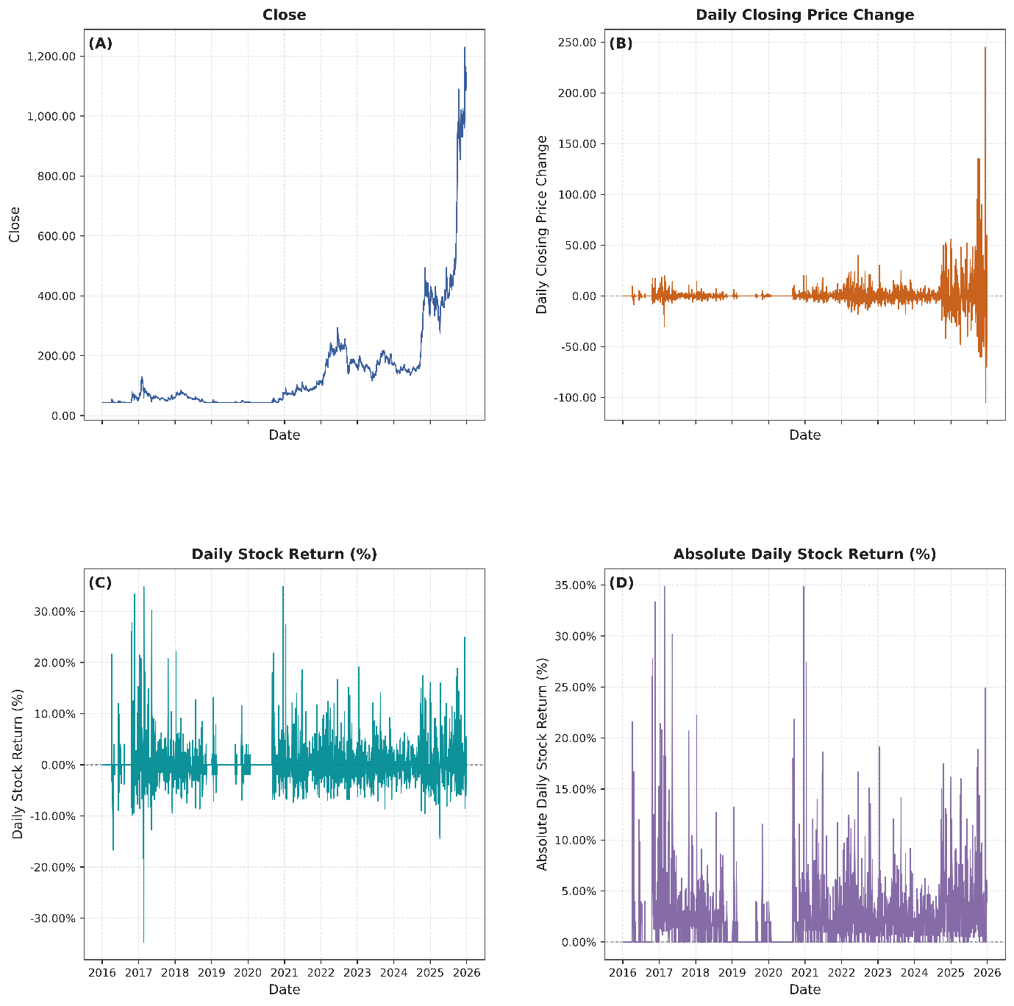
Figure 1 Time-Series Dynamics of Closing Price, Daily Closing-Price Change, Daily Stock Return, and Absolute Daily Stock Return of PT Bumi Resources Minerals Tbk (BRMS.JK), 2016–2025
Note. Panel A presents the daily closing price; Panel B presents the daily closing-price change; Panel C presents the signed daily stock return; and Panel D presents the absolute daily stock return.

Figure 1 shows a low-price regime in the early sample followed by a pronounced rise toward 2024–2025, with the sample closing-price maximum of IDR 1,230 reached in December 2025. Daily price changes and returns remained concentrated near zero for much of the period but contained isolated positive and negative extremes. Absolute returns confirm that most observations were moderate relative to a small set of large tail movements.
Table 1. Descriptive Statistics of Closing-Price Levels, Changes, and Returns of PT Bumi Resources Minerals Tbk (BRMS.JK), 2016–2025
Variable | Minimum | Maximum | Mean | Standard Deviation
Close | 43.61 | 1230 | 150.4345 | 179.5334
Daily Closing Price Change | -105 | 245 | 0.4422 | 11.4761
Daily Stock Return (%) | -34.6464 | 34.8445 | 0.2186 | 4.1805
Absolute Daily Stock Return (%) | 0 | 34.8445 | 2.3635 | 3.4549
Note. Descriptive statistics for the closing price are based on 2,390 retained trading observations. Statistics for daily closing-price change, daily stock return, and absolute daily stock return are based on 2,389 valid paired observations.

Table 1 summarizes the dispersion underlying the figure. Closing prices ranged from IDR 43.61 to IDR 1,230 (mean 150.4345), while daily returns ranged from −34.6464% to 34.8445% (mean 0.2186%, SD 4.1805%). The mean absolute return was 2.3635%, indicating that the largest daily moves were far larger than the typical observation.
To examine how the daily price dynamics accumulated at the annual level, Table 2 reports the initial and final closing prices, absolute price changes, and percentage price changes for each calendar year.
Table 2. Annual Closing-Price Performance and Observation Coverage of PT Bumi Resources Minerals Tbk (BRMS.JK), 2016–2025
Year | Observation Period | Initial Closing Price (IDR) | Final Closing Price (IDR) | Absolute Closing Price Change (IDR) | Percentage Closing Price Change (%) | Annual Price Movement
2016 | 2016-01-04 – 2016-12-30 | 43.61 | 58.44 | 14.83 | 34.01 | Increase
2017 | 2017-01-03 – 2017-12-29 | 56.69 | 57.57 | 0.88 | 1.55 | Increase
2018 | 2018-01-02 – 2018-12-28 | 58.44 | 43.61 | -14.83 | -25.38 | Decrease
2019 | 2019-01-02 – 2019-12-30 | 43.61 | 45.35 | 1.74 | 3.99 | Increase
2020 | 2020-01-02 – 2020-12-30 | 44.48 | 72.39 | 27.91 | 62.75 | Increase
2021 | 2021-01-04 – 2021-12-30 | 75.88 | 116.00 | 40.12 | 52.87 | Increase
2022 | 2022-01-03 – 2022-12-30 | 112.00 | 159.00 | 47.00 | 41.96 | Increase
2023 | 2023-01-02 – 2023-12-29 | 160.00 | 170.00 | 10.00 | 6.25 | Increase
2024 | 2024-01-02 – 2024-12-30 | 175.00 | 346.00 | 171.00 | 97.71 | Increase
2025 | 2025-01-02 – 2025-12-30 | 402.00 | 1,100.00 | 698.00 | 173.63 | Increase
Note. The initial and final closing prices correspond to the first and last retained trading observations within each calendar year. Percentage closing-price change is calculated as the difference between the final and initial closing prices divided by the initial closing price and multiplied by 100.

Table 2 shows positive first-to-final annual closing-price performance in nine of ten years. The only annual decline was −25.38% in 2018. Appreciation strengthened after 2020 and was largest in 2025, when the closing price rose from IDR 402 to IDR 1,100 (+173.63%). The December 2025 sample maximum of IDR 1,230 occurred before the final retained trading observation and therefore differs from the year-end value.
Because positive annual performance does not necessarily imply that positive daily movements occurred more frequently than negative or unchanged movements, Table 3 decomposes the observations into daily decreases, unchanged prices, and daily increases.
Table 3. Annual Frequency and Percentage Distribution of Daily Stock-Price Movement Directions of PT Bumi Resources Minerals Tbk (BRMS.JK), 2016–2025
Year | Decrease |  | Unchanged |  | Increase
 | f | % | f | % | f | %
2016 | 44 | 18.64 | 165 | 69.92 | 27 | 11.44
2017 | 124 | 52.54 | 34 | 14.41 | 78 | 33.05
2018 | 84 | 36.05 | 89 | 38.20 | 60 | 25.75
2019 | 30 | 12.61 | 184 | 77.31 | 24 | 10.08
2020 | 45 | 18.60 | 163 | 67.36 | 34 | 14.05
2021 | 111 | 45.12 | 40 | 16.26 | 95 | 38.62
2022 | 127 | 51.63 | 25 | 10.16 | 94 | 38.21
2023 | 120 | 50.21 | 22 | 9.21 | 97 | 40.59
2024 | 101 | 42.62 | 27 | 11.39 | 109 | 45.99
2025 | 115 | 48.73 | 15 | 6.36 | 106 | 44.92
Note. Percentages are calculated relative to the valid daily price-movement observations within each year. The first retained sample observation is excluded because no preceding closing price is available.

Despite the predominantly positive annual outcomes, daily decreases were the most frequent direction across the 2,389 paired observations: 901 decreases (37.71%), 764 unchanged observations (31.98%), and 724 increases (30.31%). Thus, annual appreciation reflected the magnitude and sequence of daily movements rather than simply the number of positive days.
The annual composition of daily directions varied substantially. Unchanged prices were especially prominent in 2016, 2019, and 2020, while decreases were the largest category in several later years. By 2025, unchanged observations represented only a small fraction of valid trading days. Figure 2 therefore adds information beyond the annual first-to-final returns: it shows that the path toward higher year-end prices became increasingly dominated by active upward and downward movements rather than by long sequences of unchanged closes.
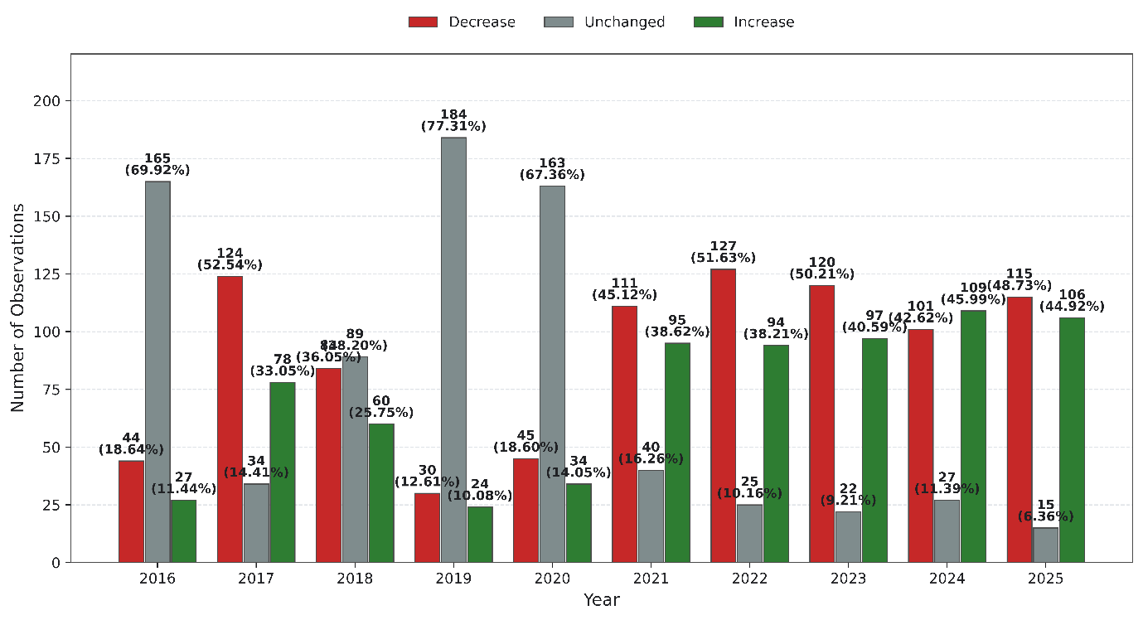
Figure 2 Annual Frequency and Percentage Distribution of Daily Stock-Price Movement Directions of PT Bumi Resources Minerals Tbk (BRMS.JK), 2016–2025
Note. Bar height represents frequency. Data labels report the corresponding frequency and percentage within each year.

Using the 8.0953% empirical threshold, 120 price anomalies were identified. Table 4 and Figure 3 show a strong directional imbalance toward Sharp Price Increases.

Table 4. Annual Frequency and Percentage Distribution of Sharp Price-Anomaly Categories of PT Bumi Resources Minerals Tbk (BRMS.JK), 2016–2025
Year | Sharp Price Increase |  | Sharp Price Decrease |  | Total
 | f | % | f | % | f | %
2016 | 11 | 61.11 | 7 | 38.89 | 18 | 100.00
2017 | 16 | 69.57 | 7 | 30.43 | 23 | 100.00
2018 | 4 | 66.67 | 2 | 33.33 | 6 | 100.00
2019 | 2 | 100.00 | 0 | 0.00 | 2 | 100.00
2020 | 7 | 100.00 | 0 | 0.00 | 7 | 100.00
2021 | 9 | 100.00 | 0 | 0.00 | 9 | 100.00
2022 | 14 | 100.00 | 0 | 0.00 | 14 | 100.00
2023 | 6 | 85.71 | 1 | 14.29 | 7 | 100.00
2024 | 9 | 81.82 | 2 | 18.18 | 11 | 100.00
2025 | 20 | 86.96 | 3 | 13.04 | 23 | 100.00
Note. Percentages are calculated relative to the total number of price anomalies identified within each year. A daily return greater than 8.0953% is classified as a Sharp Price Increase, while a return below −8.0953% is classified as a Sharp Price Decrease.

Of the 120 price anomalies, 98 (81.67%) were Sharp Price Increases and 22 (18.33%) were Sharp Price Decreases. Upward anomalies outnumbered downward anomalies in every year, and no Sharp Price Decrease was identified from 2019 through 2022. The largest yearly anomaly counts occurred in 2017 and 2025, with 23 events in each year. The ten largest absolute returns are reported in Supplementary Table S2.
The annual price-anomaly distribution was also uneven. The largest numbers of price anomalies occurred in 2017 and 2025, with 23 events in each year, but their directional composition differed: 2017 contained both sharp increases and decreases, whereas 2025 was heavily weighted toward increases. From 2019 through 2022 every identified price anomaly was upward. Figure 3 makes this asymmetry visible across years and confirms that the dominance of Sharp Price Increases was not confined to one isolated calendar period.

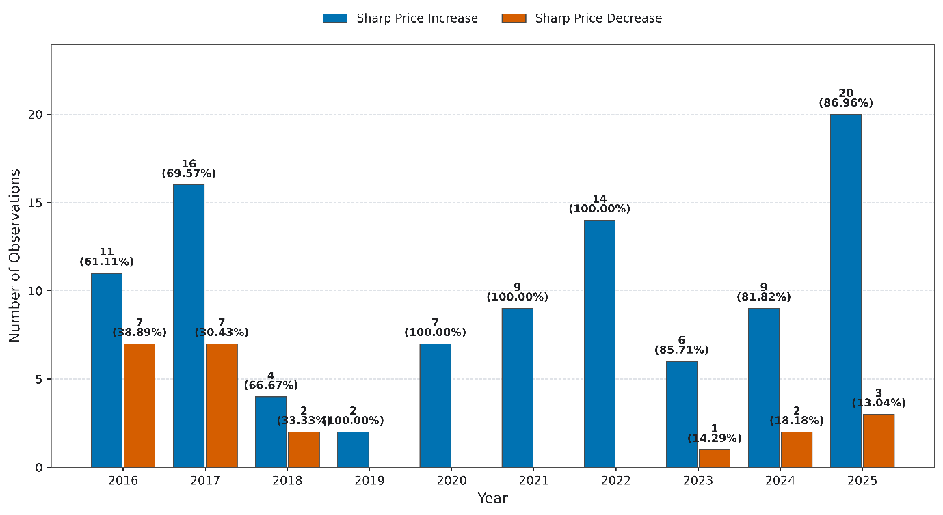
Figure 3 Annual Frequency and Percentage Distribution of Sharp Price-Anomaly Categories of PT Bumi Resources Minerals Tbk (BRMS.JK), 2016–2025
Note. Bar height represents the annual anomaly frequency. Data labels report the frequency and percentage of each category relative to the total price anomalies identified within the corresponding year.

3.2. Trading-Volume Dynamics and Volume Anomalies
Figure 4 summarizes BRMS trading-volume dynamics in levels, absolute share changes, signed percentage changes, and absolute percentage changes. Volume was highly episodic, with several multi-billion-share peaks. Percentage changes display much greater visual asymmetry because a small number of very large positive changes dominate the scale.

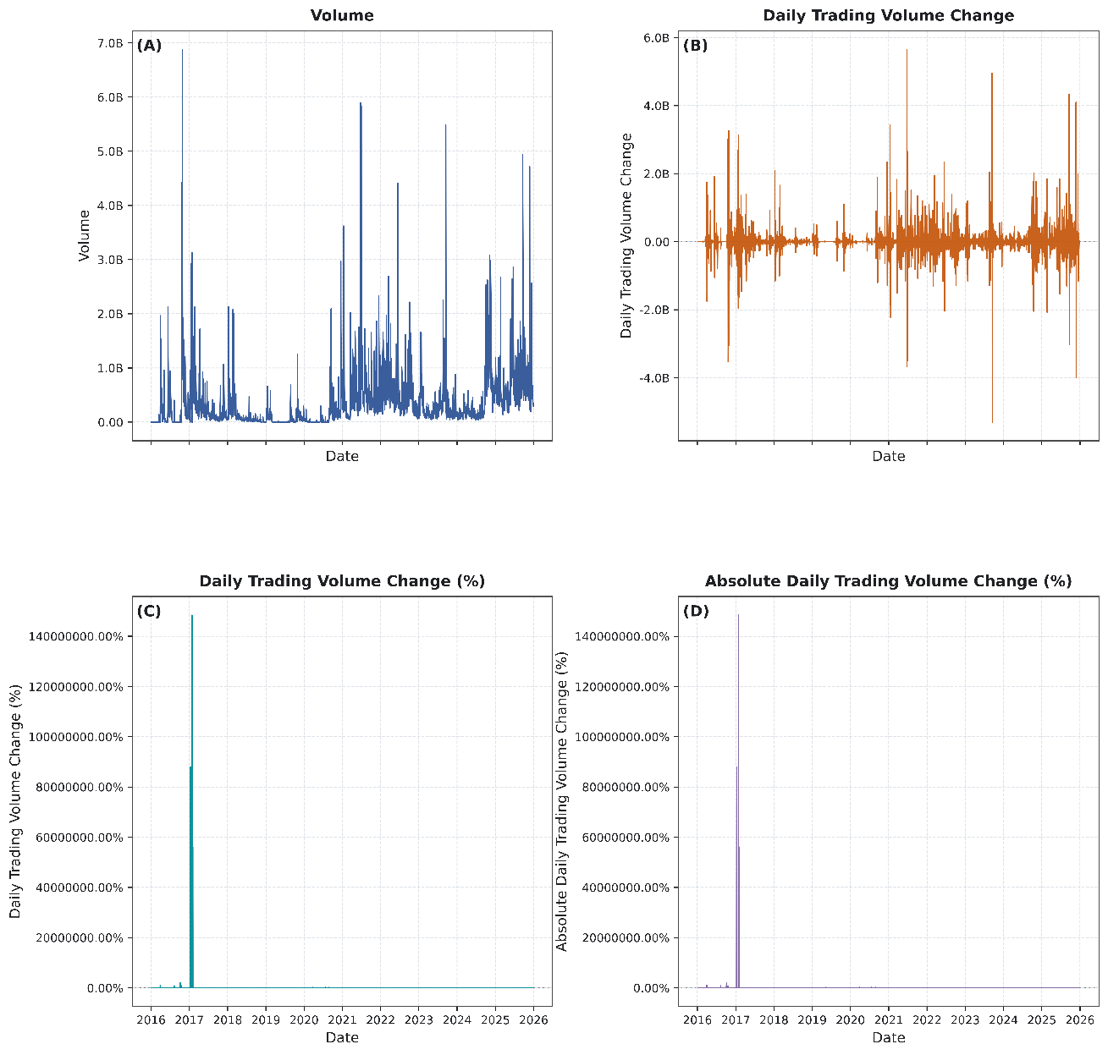
Figure 4 Time-Series Dynamics of Trading Volume, Daily Trading-Volume Change, Daily Trading-Volume Change (%), and Absolute Daily Trading-Volume Change (%) of PT Bumi Resources Minerals Tbk (BRMS.JK), 2016–2025
Note. Panel A presents daily trading volume; Panel B presents the change in trading volume relative to the immediately preceding retained trading observation; Panel C presents the corresponding percentage change; and Panel D presents the absolute magnitude of the daily percentage change in trading volume.

The highest retained daily volume was 6.879 billion shares, while the largest absolute increase and decrease in daily volume were approximately +5.650 billion and −5.305 billion shares. These large level changes occurred at several points in the sample rather than in a single year.
The percentage measure is especially sensitive to low preceding-volume bases. Because positive proportional increases are unbounded whereas declines approach −100%, percentage changes can appear extremely large when a very small prior volume is followed by ordinary or high trading activity.
To complement the time-series visualization and quantify the dispersion observed across the four panels, Table 5 reports the minimum, maximum, mean, and standard deviation of daily trading volume and the corresponding absolute and percentage changes.

Table 5. Descriptive Statistics of Trading Volume and Daily Trading-Volume Changes of PT Bumi Resources Minerals Tbk (BRMS.JK), 2016–2025
Variable | Minimum | Maximum | Mean | Standard Deviation
Volume | 114 | 6879489073 | 363543127.3812 | 569400297.8313
Daily Trading Volume Change | -5304659900 | 5649823018 | 121270.5856 | 493525205.1351
Daily Trading Volume Change (%) | -99.9999 | 148418425.7482 | 124991.3269 | 3710664.0254
Absolute Daily Trading Volume Change (%) | 0.0000 | 148418425.7482 | 125038.3035 | 3710662.4421
Note. Trading volume is measured in shares. Daily Trading Volume Change represents the difference between the current and immediately preceding retained trading observations. Percentage changes are calculated relative to the preceding retained trading volume.

Table 5 quantifies this dispersion: volume ranged from 114 to 6,879,489,073 shares, and the standard deviation of volume exceeded its mean. Signed percentage changes ranged from −99.9999% to 148,418,425.7482%. These extreme summary values are driven by denominator sensitivity and should be interpreted with the underlying share volumes; detailed rankings are provided in Supplementary Tables S3–S6.
The ranked observations in the supplement clarify why the percentage distribution is so extreme. Several of the largest positive percentage changes followed preceding volumes of only hundreds or thousands of shares and then moved to millions or billions of shares. Conversely, the largest negative percentage changes clustered close to −100% because a positive volume cannot decline by more than its entire preceding base. These mechanical features do not invalidate the measure, but they explain why its arithmetic mean and standard deviation are dominated by a small set of observations.

Table 6. Annual Frequency and Percentage Distribution of Daily Trading-Volume-Change Anomaly Categories of PT Bumi Resources Minerals Tbk (BRMS.JK), 2016–2025
Year | Abnormally Large Volume Increase |  | Abnormally Large Volume Decrease |  | Total
 | f | % | f | % | f | %
2016 | 33 | 46.48 | 38 | 53.52 | 71 | 100.00
2017 | 6 | 66.67 | 3 | 33.33 | 9 | 100.00
2018 | 9 | 39.13 | 14 | 60.87 | 23 | 100.00
2019 | 24 | 47.06 | 27 | 52.94 | 51 | 100.00
2020 | 35 | 50.00 | 35 | 50.00 | 70 | 100.00
2021 | 5 | 100.00 | 0 | 0.00 | 5 | 100.00
2022 | 1 | 100.00 | 0 | 0.00 | 1 | 100.00
2023 | 5 | 71.43 | 2 | 28.57 | 7 | 100.00
2024 | 0 | 0.00 | 0 | 0.00 | 0 | 0.00
2025 | 2 | 66.67 | 1 | 33.33 | 3 | 100.00
Note. Percentages are calculated relative to the total number of trading-volume-change anomalies identified within each year. The lower and upper anomaly thresholds are −83.7761% and 637.3561%, respectively. A total of zero indicates that no trading-volume-change anomaly was identified in the corresponding year.

The 5th/95th percentile rule identified 240 volume anomalies, evenly split between 120 Abnormally Large Volume Increases and 120 Abnormally Large Volume Decreases. The balance in full-sample counts follows from the two empirical tails, but the annual allocation was highly uneven.
Volume anomalies were concentrated in the first half of the sample: 224 of 240 events (93.33%) occurred during 2016–2020, including 71 in 2016, 51 in 2019, and 70 in 2020. Only 16 occurred during 2021–2025, none in 2024. Table 6 and Figure 5 therefore show strong temporal heterogeneity under the fixed full-sample thresholds, not a tested structural break.
The yearly counts also show that the balanced full-sample tails did not translate into balanced annual behavior. Abnormally Large Volume Decreases were more frequent in some early years, while increases predominated in several later years with very few total anomalies. The sharp reduction in anomaly counts after 2020 is therefore the more informative temporal result than the 120/120 full-sample split. Under the fixed thresholds, the distribution indicates that extreme proportional changes in trading activity were concentrated in the early sample even though high absolute trading volumes continued to occur later.

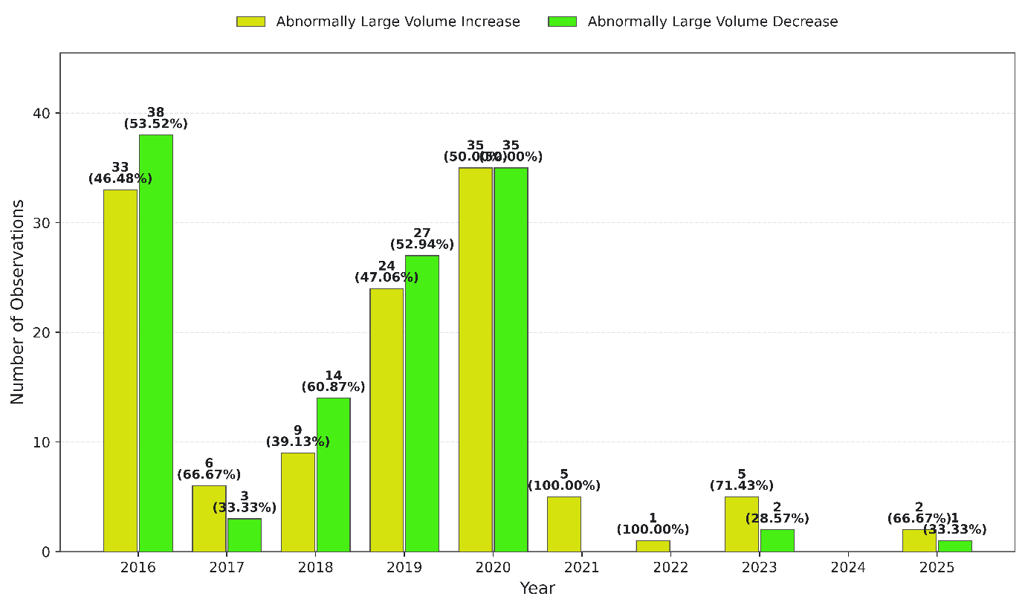
Figure 5 Annual Frequency and Percentage Distribution of Daily Trading-Volume-Change Anomaly Categories of PT Bumi Resources Minerals Tbk (BRMS.JK), 2016–2025
Note. Bar height represents frequency. Data labels report the frequency and percentage of each anomaly category relative to the total number of trading-volume-change anomalies identified within each year. No anomaly was identified in 2024.

3.3. Simultaneous Price–Volume Anomalies and Statistical Association
Across 2,389 valid paired observations, 23 simultaneous price-volume anomalies were identified; Supplementary Table S7 provides the complete event list.
Directional concentration was pronounced: 20 of 23 events (86.96%) combined a Sharp Price Increase with an Abnormally Large Volume Increase, two combined a price increase with a volume decrease, one combined a price decrease with a volume decrease, and none combined a price decrease with a volume increase.
The 23 joint events were distributed across 2016–2023 and 2025, with none in 2024. The largest annual count occurred in 2017, when six events also displayed the greatest diversity of directional combinations. From 2018 onward, joint anomalies were almost exclusively increase/increase observations. This temporal pattern supports the use of the full event list in the supplement while allowing the main text to focus on the dominant direction and aggregate association rather than narrating each date separately.
The joint classification denotes same-observation co-occurrence only. Table 7 shows that the increase/increase pattern occurred in every year with at least one joint anomaly; the greatest annual count was six events in 2017.

Table 7. Annual frequency of simultaneous price–volume anomaly combinations of PT Bumi Resources Minerals Tbk (BRMS.JK), 2016–2025
Year | Sharp Price Increase + Large Volume Increase | Sharp Price Increase + Large Volume Decrease | Sharp Price Decrease + Large Volume Increase | Sharp Price Decrease + Large Volume Decrease | Total Joint Anomaly Events
2016 | 3 | 0 | 0 | 1 | 4
2017 | 4 | 2 | 0 | 0 | 6
2018 | 1 | 0 | 0 | 0 | 1
2019 | 1 | 0 | 0 | 0 | 1
2020 | 3 | 0 | 0 | 0 | 3
2021 | 4 | 0 | 0 | 0 | 4
2022 | 1 | 0 | 0 | 0 | 1
2023 | 2 | 0 | 0 | 0 | 2
2024 | 0 | 0 | 0 | 0 | 0
2025 | 1 | 0 | 0 | 0 | 1
Note. The four joint patterns represent all possible combinations of Sharp Price Increase or Sharp Price Decrease with Abnormally Large Volume Increase or Abnormally Large Volume Decrease.

Overall, the directional distribution was therefore strongly asymmetric toward positive-price/high-volume observations, although joint anomalies themselves remained rare relative to the full sample.
To determine whether the two anomaly statuses co-occurred more frequently than expected under independence, Table 8 reports the 2 × 2 contingency results.
Table 8. Statistical association between price and trading-volume anomalies of PT Bumi Resources Minerals Tbk (BRMS.JK), 2016–2025
Measure | Estimate | p-value | Interpretation
Both price and volume anomalies | 23 |  | Observed joint events
Price anomaly only | 97 |  | Price anomaly without volume anomaly
Volume anomaly only | 217 |  | Volume anomaly without price anomaly
Neither anomaly | 2052 |  | No anomaly on either dimension
Valid paired observations | 2389 |  | Complete price–volume classifications
Expected simultaneous anomalies under independence | 12.0553 |  | Expected cell count
Pearson chi-square | 11.6304 | 0.0006 | Two-sided test of independence
Yates-corrected chi-square | 10.5921 | 0.0011 | Continuity-corrected 2 × 2 test
Sample odds ratio | 2.2422 |  | 95% CI: 1.39–3.61
Two-sided Fisher exact test | — | 0.0016 | Exact test of independence
Phi coefficient / Cramer's V | 0.0698 |  | Positive association; limited association magnitude
Minimum expected cell count | 12.0553 |  | Expected-count criterion
Association direction | Positive association |  | Based on the odds ratio
Note. Tests are based on 2,389 observations with complete price- and trading-volume-anomaly classifications. Pearson’s chi-square test is reported as the primary test of independence, with the Yates continuity correction and two-sided Fisher’s exact test reported as complementary checks. The Phi coefficient/Cramér’s V summarizes association magnitude. All reported p-values are two-sided.

Under independence, approximately 12.06 joint events were expected; 23 were observed, an observed-to-expected ratio of about 1.91. A volume anomaly occurred in 19.17% of price-anomaly observations versus 9.56% of non-price-anomaly observations.
The contingency counts were 23 observations with both anomalies, 97 with a price anomaly only, 217 with a volume anomaly only, and 2,052 with neither. These counts imply 120 price anomalies and 240 volume anomalies in the valid paired sample. Simultaneous events represented only about 0.96% of all paired observations, which is why the statistically significant dependence should be interpreted alongside the small effect-size measure rather than as a pervasive daily relationship.
Pearson's chi-square test rejected independence (χ² = 11.6304, p = 0.0006), with a minimum expected cell count of 12.0553. The Yates-corrected result was also significant (χ² = 10.5921, p = 0.0011).
The two-sided Fisher exact test was significant (p = 0.0016). Separately, the sample odds ratio was 2.2422 (95% CI: 1.39–3.61), meaning that the odds of a volume anomaly were approximately 2.24 times as high among price-anomaly observations as among non-price-anomaly observations.
Phi/Cramér's V was 0.0698, indicating limited association magnitude despite statistically detectable dependence. The result therefore supports positive co-occurrence without implying a strong, deterministic, predictive, or causal relationship.

3.4. Event- and News-Based Contextual Validation of Selected Joint Anomalies
Structured contextual validation was applied to 11 prespecified events (2, 4, 5, 7, 11, 12, 14, 16, 20, 21, and 23) using the fixed t−3 to t calendar-day window and the restricted t+1 to t+2 documentation rule. Table 9 summarizes the classifications; Supplementary Table S8 preserves the full source and timing audit.
Table 9. Summary of Event- and News-Based Contextual Validation of Selected Joint Anomalies
Event | Date | Return (%) | Volume change (%) | Evidence strength
2 | 20 Apr 2016 | −16.66 | −99.00 | Not Externally Validated
4 | 19 Oct 2016 | +26.00 | +795,118.79 | Moderate
5 | 9 Jan 2017 | +21.44 | ≈−100.00 | Not Externally Validated
7 | 26 Jan 2017 | +20.80 | ≈−100.00 | Moderate
11 | 11 Jan 2018 | +22.21 | +4,062.96 | Moderate
12 | 30 Oct 2019 | +11.55 | +747.72 | High
14 | 15 Sep 2020 | +21.83 | +950.68 | Not Externally Validated
16 | 13 Jan 2021 | +27.38 | +1,848.93 | Not Externally Validated
20 | 21 Jan 2022 | +9.01 | +758.75 | Not Externally Validated
21 | 16 Jan 2023 | +19.11 | +897.52 | Moderate
23 | 19 Sep 2025 | +17.12 | +720.72 | High
Note. Detailed contextual evidence, source citations, and timing-audit information are provided in Supplementary Table S8. Contextual correspondence is descriptive and does not establish causal attribution.

Two events received High classifications. On 30 October 2019, same-day reporting documented positive 9M 2019 financial results and expected progress at the Poboya gold operation, corresponding with an 11.55% price increase and 747.72% volume increase (PT Bumi Resources Minerals Tbk, 2019; Sulmaihati, 2019).
The second High event occurred on 19 September 2025. VanEck's 17 September documentation identified BRMS as a new pro forma MarketVector Global Gold Miners Index constituent at a 0.61% weight; the implementation date coincided with a 17.12% price increase and a 720.72% volume increase (Putri, 2025; Tim Riset IDX Channel, 2025; VanEck, 2025). This is strong temporal and security-specific correspondence, not proof that index inclusion was the sole cause of the movement.
Four events were classified Moderate because the available evidence was indirect, group-level, market-wide, temporally less precise, or internally inconsistent with one dimension of the fixed anomaly classification. The audit retained such ambiguity rather than upgrading events on the basis of a plausible narrative.
The Moderate category captured several different forms of incomplete correspondence. Some cases involved Bakrie-group or broad market information that was directionally consistent with the BRMS price movement but not sufficiently issuer-specific. One January 2017 event also contained tension between external descriptions of active trading and the fixed Yahoo-based classification of a large volume decrease. Retaining that inconsistency in the audit was preferable to forcing the event into a stronger category and illustrates why source credibility and directional consistency were evaluated separately.
Five events were Not Externally Validated because sufficiently specific, credible, and temporally eligible public information could not be established under the protocol. Some plausible corporate information fell outside the fixed window and was therefore excluded. This classification does not imply that no information existed or that undocumented mechanisms caused the events.
Three of the Not Externally Validated cases had economically relevant information near the event date but outside the prespecified window. The 2020 first-half result, 2021 rights-issue information, and 2022 rights-issue completion were therefore excluded from the qualifying evidence set despite their apparent relevance. This timing discipline is central to the contextual design because expanding the window after observing the anomaly would increase the risk of post hoc explanation.
The final distribution—2 High, 4 Moderate, and 5 Not Externally Validated—shows that aggregate statistical dependence and event-level documentary correspondence are distinct evidence layers. Neither layer, separately or jointly, establishes causal attribution.

4. Discussion
The results are best interpreted as complementary layers rather than a single mechanism. Long-horizon performance describes net price evolution; tail classifications identify unusual observations; contingency analysis tests whether binary anomaly statuses depart from independence; and documentary validation evaluates public-information correspondence for selected events. Keeping these layers separate is essential because statistical co-occurrence does not explain an event, and documentary correspondence does not estimate a counterfactual causal effect.

4.1. Long-Term Price Performance and Daily Return Dynamics
BRMS displayed a notable contrast between long-horizon performance and daily directional frequency. Nine of ten years ended with a higher closing price, yet daily decreases were more frequent than daily increases. This is consistent with the arithmetic of cumulative performance: a smaller number of sufficiently large gains can outweigh a larger number of smaller losses. The finding therefore illustrates why sign frequency, return magnitude, and horizon should not be treated as interchangeable measures of market performance.
This distinction has a direct interpretive implication for empirical studies of long-horizon stock performance. A positive annual endpoint does not indicate that investors encountered predominantly positive daily movements, just as a high frequency of negative days does not imply a negative annual return. For BRMS, the coexistence of nine positive annual outcomes with more frequent daily declines highlights the role of return size and sequence. The result therefore supports reporting both horizon-level performance and daily distributional behavior when a study is concerned with unusual price movements.
The presence of several large absolute returns reinforces the importance of tail analysis. Unconditional averages compress these observations, whereas the empirical-tail framework makes their direction and timing explicit. The strong appreciation in 2024–2025 remains descriptive, however; the study does not test momentum, sentiment, commodity exposure, or structural regime changes.

4.2. Asymmetry and Temporal Distribution of Price and Trading-Volume Anomalies
Price anomalies were strongly asymmetric: 81.67% were Sharp Price Increases. This security-specific pattern is consistent with the broader observation that positive and negative extreme returns can exhibit different behavior (Ciner, 2015; Larson & Madura, 2003; Lin & González-Rivera, 2019), but it should not be generalized to Indonesian mining stocks as a class. Tail composition depends on the security, sample, market environment, and operational definition.
The asymmetry is also consistent with the descriptive path of the security, which experienced several episodes of sharp appreciation. Even so, the percentile rule is endogenous to the BRMS sample: a different observation window would change the empirical return distribution and therefore the anomaly boundary. The finding should consequently be described as a property of this retained sample rather than evidence that upward extremes are generally more common in mining equities or in the Indonesian market.
The volume results show a different type of heterogeneity. Although lower- and upper-tail anomaly counts were balanced over the full sample, 93.33% of volume anomalies occurred during 2016–2020. This concentration is compatible with the highly heterogeneous nature of trading activity documented in prior work (Ajinkya & Jain, 1989; Gervais et al., 2001), but the present design does not identify a structural break or liquidity regime.
Interpretation of the volume tail must also account for denominator sensitivity. The most extreme positive percentage changes frequently followed exceptionally small preceding volumes; positive changes are unbounded, whereas declines approach −100%. Accordingly, the percentage metric identifies proportional extremes but should be read together with underlying share volumes rather than as a direct measure of liquidity, depth, or economic importance.
This issue illustrates a broader measurement point. Percentage transformations are useful because they place volume changes on a relative scale, but they can amplify low-base observations in a way that raw share changes do not. The study addresses this by preserving both metrics and by moving ranked underlying-volume observations to the supplement. Future applications may compare this signed percentage rule with rolling relative-volume or standardized alternatives, but those extensions would change the anomaly definition and therefore answer a different robustness question.

4.3. Joint Price-Volume Anomalies and Statistical Association
The joint-anomaly results provide the central link between price and trading activity. Twenty of the 23 joint events were increase/increase observations, a directional concentration broadly consistent with classic evidence that price changes and volume can be positively related (Campbell et al., 1993; Gallant et al., 1992; Karpoff, 1987). Yet only 23 of 2,389 observations were joint anomalies, so the pattern was concentrated in direction but rare in frequency.
The contingency analysis shows that this co-occurrence exceeded what statistical independence would imply: 23 joint events were observed versus about 12.06 expected. Pearson, Yates-corrected, and Fisher tests all indicated dependence. The odds ratio of 2.24 summarizes relative odds, not probability, and does not establish whether volume led price or price led volume.
The observed-to-expected ratio of about 1.91 is useful as a descriptive complement to the inferential tests because it makes the excess co-occurrence directly interpretable. However, it should not be read as a probability multiplier. Similarly, the odds ratio compares odds across anomaly-status groups and is not equivalent to a risk ratio. These distinctions matter because translating the estimate into 'times more likely' would overstate what the 2 × 2 table establishes.
Magnitude remains crucial. Phi/Cramér's V of approximately 0.070 indicates limited association magnitude even though the departure from independence was statistically detectable. This distinction follows the broader principle that statistical significance is not a measure of effect size or practical importance (Wasserstein & Lazar, 2016). The evidence therefore supports a positive but limited contemporaneous association, not a strong or predictive relationship.
The limited value of V also places the 20 increase/increase events in perspective. Directional concentration among the joint events is visually striking, but the binary association across all 2,389 observations remains small in numerical magnitude. A coherent interpretation therefore requires both statements: joint tail events occurred more often than independence predicts and were usually positive-price/high-volume observations, yet the overall dependence between the anomaly indicators was limited.

4.4. Contextual Evidence and Event-Level Heterogeneity
The contextual results reinforce the distinction between aggregate dependence and event-level explanation. Only 2 of 11 prespecified events were classified High, while 4 were Moderate and 5 were Not Externally Validated. This heterogeneity is conceptually consistent with evidence that extreme returns may or may not coincide with readily identifiable public information (Larson & Madura, 2003). It also cautions against assuming that every statistically unusual observation has a single observable catalyst.
The two High cases also demonstrate that strong documentary correspondence can arise through different information channels. The 2019 case involved issuer financial and operational information, whereas the 2025 case involved a security-specific index transition. Their common feature is not the type of information but the combination of issuer relevance, temporal eligibility, source credibility, and directional consistency. This supports the use of criteria-based validation rather than restricting the contextual stage to one predetermined class of news.
The 2019 High event involved issuer-specific financial and operational information contemporaneous with the anomaly. The relevance of accounting information to market activity is well established (Ball & Brown, 1968; Beaver, 1968), but those studies do not establish causality for BRMS. Here, the evidence supports contemporaneous correspondence only.
The 2025 High event involved pre-event documentation of BRMS inclusion in a gold-mining index. Index-composition changes can be associated with price and volume effects (Vespro, 2006), although the index effect has weakened in more recent evidence (Greenwood & Sammon, 2025). The balanced interpretation is therefore strong documentary correspondence with a security-specific index event, not proof of a mechanically determined price or flow effect.
Moderate and Not Externally Validated cases are equally informative because they preserve uncertainty. The fixed timing rule prevented plausible but out-of-window information from being admitted ex post. Not Externally Validated consequently means that qualifying public evidence could not be established under the protocol; it is not evidence of private information, manipulation, sentiment, liquidity shocks, or the absence of any information event.
The large share of non-High classifications is substantively important because it prevents the aggregate association from being converted into a narrative that every joint anomaly had a readily observable public explanation. Public archives are incomplete, and the protocol cannot rule out information that was unavailable, poorly preserved, or disseminated through channels not captured by the search. The appropriate conclusion is therefore evidence heterogeneity, not evidence absence.
The central synthesis is that statistical dependence and documentary correspondence are non-equivalent forms of evidence. BRMS anomaly statuses co-occurred more often than expected under independence, but the association magnitude was limited and strong documentary correspondence was identified for only a minority of audited events. A uniform information mechanism is therefore not supported by the design.

4.5. Empirical and Practical Implications
For empirical finance, the framework shows the value of separating tail identification, joint occurrence, association magnitude, and documentary context. These layers answer different questions and reduce the risk of treating an anomaly label as an explanation. For investors and analysts, joint price-volume anomalies may be useful screening observations that motivate closer review of disclosures, index changes, sector conditions, or market-wide information; the study does not show that they predict subsequent returns.
This separation may be especially useful in emerging-market settings where market data and historical disclosure archives can differ in availability and quality across time. A reproducible anomaly screen can identify candidate dates consistently, after which documentary review can be conducted under an explicit source and timing protocol. The sequence does not solve identification problems, but it makes clear which conclusions arise from the market data and which arise from external documentary evidence.
For market screening or surveillance, the same logic applies: unusual price-volume co-occurrence can identify observations warranting review, but it is not evidence of manipulation, insider trading, misconduct, or a regulatory violation. The practical contribution is therefore procedural and diagnostic rather than predictive or accusatory.
For practitioners, the framework is therefore most defensible as a prioritization device. A joint anomaly may justify closer examination because two market dimensions are simultaneously unusual, while the subsequent contextual stage can indicate whether a credible public-information correspondence is readily observable. Neither step determines whether the movement was justified, profitable to trade, or associated with misconduct. Those questions require different data and research designs.

5. Limitations and Future Research
Several limitations bound the inference. The study examines one security over 2016–2025, so the observed directional asymmetry, temporal concentration, joint patterns, and contextual outcomes are security- and sample-specific. The percentile thresholds are also empirical operational rules: different securities, windows, or anomaly definitions can generate different event sets. Daily data and close-to-close returns do not reveal intraday sequencing or explicit total shareholder return.
The percentage-based volume measure is sensitive to the immediately preceding trading-volume denominator; very small prior volumes can create extremely large positive percentage changes. Underlying share volumes were therefore retained for interpretation, but the measure should not be read as a direct proxy for liquidity or market depth.
Yahoo Finance served as a secondary historical-data interface. Although the workflow preserves cleaning rules, exclusions, chronology, thresholds, and audit files, future replication could compare the results with other verified market-data sources. Documentary validation is also constrained by historical page availability, timestamp quality, and archival completeness, so Not Externally Validated does not mean that no relevant information existed.
Finally, the statistical and contextual components are noncausal by design. They do not estimate lead-lag effects, expected or abnormal returns, cumulative abnormal returns, or a market-model counterfactual. Future research could apply the framework across Indonesian mining securities, use intraday data, compare alternative tail or relative-volume definitions, and conduct formal market- or sector-adjusted event studies. These extensions address different questions rather than correcting the present descriptive-associational design.

6. Conclusions
This study examined BRMS daily price and trading-volume dynamics over 2016–2025 by integrating long-horizon characterization, empirical tail classification, same-observation joint-anomaly mapping, contingency-based association testing, and prespecified documentary validation. The contribution lies in combining established analytical components into a transparent issuer-level analysis from an emerging capital market while maintaining a strict distinction between statistical dependence and causal interpretation.
The empirical tails were asymmetric across direction and time. Of 120 price anomalies, 98 were Sharp Price Increases, while 224 of 240 volume anomalies occurred during 2016–2020. Twenty-three simultaneous anomalies were identified, including 20 increase/increase events. The observed joint count exceeded the approximately 12.06 expected under independence, and the sample odds ratio was 2.24 (95% CI: 1.39–3.61), but Phi/Cramér's V of approximately 0.070 indicated limited association magnitude.
Documentary validation produced 2 High, 4 Moderate, and 5 Not Externally Validated classifications. Thus, aggregate co-occurrence and event-specific public-information correspondence represent distinct evidence layers. Joint price-volume anomalies are most appropriately treated as reproducible screening observations for further investigation, not as standalone evidence of prediction, market misconduct, or a common causal mechanism.

Ethics Statement
Ethical approval and informed consent were not applicable to the present study because the analysis relied exclusively on publicly available secondary financial-market data and publicly accessible documentary sources. The study involved no human participants, animals, surveys, interviews, experimental interventions, or personally identifiable or sensitive individual-level information.

Author contributions
Abdillah Arif Nasution: Conceptualization, Formal analysis, Writing – original draft, Writing – review & editing, Supervision, Project administration. Aulia Arif Nasution: Data curation, Validation. Prana Ugiana Gio: Methodology, Software, Investigation, Visualization.

Funding
The authors report that no funding was obtained for this study.

Disclosure statement
The authors report there are no competing interests to declare.

Data Availability Statement
The underlying historical market data used in this study are publicly accessible through Yahoo Finance. The archived MHTML source snapshot used for the analysis, cleaned analytical workbook, derived tables, calculation outputs, and computational audit files are available from the corresponding author upon reasonable request.

Declaration of generative AI use
During the preparation of this manuscript, the authors used OpenAI's ChatGPT to assist with language editing, sentence restructuring, academic readability, structural organization, and drafting support for selected manuscript sections. The tool was not used autonomously to collect or modify the underlying financial-market data, execute the statistical analyses, determine the anomaly classifications, or make final scientific decisions. All AI-assisted text, interpretations, methodological descriptions, and cited sources were critically reviewed, independently checked where appropriate, and revised by the authors. The authors take full responsibility for the accuracy, integrity, originality, interpretation, and final content of the manuscript.

References
Agresti, A. (2013). Categorical data analysis (3rd ed.). Wiley.
Ahadiat, A., Kesumah, F. S. D., Azhar, R., & Wisnu, F. K. (2023). Strategic decision-making on mining sector company stock prices and economic variable (State Space Model Application). International Journal of Energy Economics and Policy, 13(3), 177–184. https://doi.org/10.32479/ijeep.14171
Ajinkya, B. B., & Jain, P. C. (1989). The behavior of daily stock market trading volume. Journal of Accounting and Economics, 11(4), 331–359. https://doi.org/10.1016/0165-4101(89)90018-9
Ball, R., & Brown, P. (1968). An empirical evaluation of accounting income numbers. Journal of Accounting Research, 6(2), 159–178. https://doi.org/10.2307/2490232
Barber, B. M., & Odean, T. (2008). All that glitters: The effect of attention and news on the buying behavior of individual and institutional investors. The Review of Financial Studies, 21(2), 785–818. https://doi.org/10.1093/rfs/hhm079
Baur, D. G., Prange, P., & Schweikert, K. (2021). Flight to quality—Gold mining shares versus gold bullion. Journal of International Financial Markets, Institutions and Money, 71, 101296. https://doi.org/10.1016/j.intfin.2021.101296
Beaver, W. H. (1968). The information content of annual earnings announcements. Journal of Accounting Research, 6, 67–92. https://doi.org/10.2307/2490070
Campbell, J. Y., Grossman, S. J., & Wang, J. (1993). Trading volume and serial correlation in stock returns. The Quarterly Journal of Economics, 108(4), 905–939. https://doi.org/10.2307/2118454
Campbell, J. Y., Lo, A. W., & MacKinlay, A. C. (1997). The econometrics of financial markets. Princeton University Press.
Ciner, C. (2015). Time variation in systematic risk, returns and trading volume: Evidence from precious metals mining stocks. International Review of Financial Analysis, 41, 277–283. https://doi.org/10.1016/j.irfa.2015.01.019
Ding, Z., Granger, C. W. J., & Engle, R. F. (1993). A long memory property of stock market returns and a new model. Journal of Empirical Finance, 1(1), 83–106. https://doi.org/10.1016/0927-5398(93)90006-D
Endri, E., Rinaldi, M., Arifian, D., Saing, B., & Aminudin, A. (2021). Oil price and stock return: Evidence of mining companies in Indonesia. International Journal of Energy Economics and Policy, 11(2), 110–114. https://doi.org/10.32479/ijeep.10608
Engelberg, J. E., & Parsons, C. A. (2011). The causal impact of media in financial markets. The Journal of Finance, 66(1), 67–97. https://doi.org/10.1111/j.1540-6261.2010.01626.x
Fisher, R. A. (1922). On the interpretation of χ² from contingency tables, and the calculation of P. Journal of the Royal Statistical Society, 85(1), 87–94. https://doi.org/10.1111/j.2397-2335.1922.tb00768.x
Gallant, A. R., Rossi, P. E., & Tauchen, G. (1992). Stock prices and volume. The Review of Financial Studies, 5(2), 199–242. https://doi.org/10.1093/rfs/5.2.199
Gervais, S., Kaniel, R., & Mingelgrin, D. H. (2001). The high-volume return premium. The Journal of Finance, 56(3), 877–919. https://doi.org/10.1111/0022-1082.00349
Greenwood, R., & Sammon, M. (2025). The disappearing index effect. The Journal of Finance, 80(2), 657–698. https://doi.org/10.1111/jofi.13410
Hyndman, R. J., & Fan, Y. (1996). Sample quantiles in statistical packages. The American Statistician, 50(4), 361–365. https://doi.org/10.1080/00031305.1996.10473566
Karpoff, J. M. (1987). The relation between price changes and trading volume: A survey. Journal of Financial and Quantitative Analysis, 22(1), 109–126. https://doi.org/10.2307/2330874
Kothari, S. P., & Warner, J. B. (2007). Econometrics of event studies. In B. E. Eckbo (Ed.), Handbook of empirical corporate finance (Vol. 1, pp. 3–36). Elsevier. https://doi.org/10.1016/B978-0-444-53265-7.50015-9
Larson, S. J., & Madura, J. (2003). What drives stock price behavior following extreme one-day returns. Journal of Financial Research, 26(1), 113–127. https://doi.org/10.1111/1475-6803.00048
Lin, E. M. H., & González-Rivera, G. (2019). Extreme returns and intensity of trading. Journal of Applied Econometrics, 34(7), 1121–1140. https://doi.org/10.1002/jae.2738
Peress, J. (2014). The media and the diffusion of information in financial markets: Evidence from newspaper strikes. The Journal of Finance, 69(5), 2007–2043. https://doi.org/10.1111/jofi.12179
Pungkasanti, P. T., Christanto, F. W., Hajjas Sabat, F. T., Dewi, C., & Firdaus, E. A. (2026). Python-based stock price prediction using backpropagation neural networks: A case study on ANTM. Bulletin of Electrical Engineering and Informatics, 15(1), 723–730. https://doi.org/10.11591/eei.v15i1.9760
Putra, A. R., & Robiyanto, R. (2019). The effect of commodity price changes and USD/IDR exchange rate on Indonesian mining companies’ stock return. Jurnal Keuangan dan Perbankan, 23(1). https://doi.org/10.26905/jkdp.v23i1.2084
Qin, Y., Cai, X., Wang, M., & Webb, R. I. (2023). Gold-mining stocks, risk factors, and tail patterns. Journal of International Financial Markets, Institutions and Money, 88, 101823. https://doi.org/10.1016/j.intfin.2023.101823
Vespro, C. (2006). Stock price and volume effects associated with compositional changes in European stock indices. European Financial Management, 12(1), 103–127. https://doi.org/10.1111/j.1354-7798.2006.00312.x
Wasserstein, R. L., & Lazar, N. A. (2016). The ASA statement on p-values: Context, process, and purpose. The American Statistician, 70(2), 129–133. https://doi.org/10.1080/00031305.2016.1154108
Yates, F. (1934). Contingency tables involving small numbers and the χ² test. Supplement to the Journal of the Royal Statistical Society, 1(2), 217–235. https://doi.org/10.2307/2983604
Yahoo Finance. (n.d.). BRMS.JK historical data. https://finance.yahoo.com/quote/BRMS.JK/history/. Accessed August 5, 2026.

Web References
PT Bumi Resources Minerals Tbk. (2019). BRMS Booked Positive 9M 2019 Financial Results and Expects Palu Gold Mine to Start Operation Soon. https://www.bumiresourcesminerals.com/download/brms-booked-positive-9m-2019-financial-results-and-expects-palu-gold-mine-to-start-operation-soon-indonesian/. Accessed August 8, 2026.
Putri, K. (2025, September 16). Analis Ungkap Target Baru Saham BRMS, Harga Bisa Tembus Rp 750 Apa Penopangnya? Katadata. https://katadata.co.id/finansial/bursa/68c8a7a85bc57/analis-ungkap-target-baru-saham-brms-harga-bisa-tembus-rp-750-apa-penopangnya. Accessed August 8, 2026.
Sulmaihati, F. (2019, October 30). Setelah Rugi, Emiten Grup Bakrie Ini Akhirnya Cetak Untung Rp 14 M. Katadata. https://katadata.co.id/finansial/bursa/5e9a4e56961ad/setelah-rugi-emiten-grup-bakrie-ini-akhirnya-cetak-untung-rp-14-m. Accessed August 8, 2026.
Tim Riset IDX Channel. (2025, September 20). Saham BRMS Melejit usai Masuk VanEck Gold Miners ETF, Simak Proyeksi Terbaru. IDXChannel. https://www.idxchannel.com/market-news/saham-brms-melejit-usai-masuk-vaneck-gold-miners-etf-simak-proyeksi-terbaru. Accessed August 8, 2026.
VanEck. (2025, September 17). Updated Analysis Ahead of GDX Index Change. https://www.vaneck.com/offshore/en/news-and-insights/blogs/gold-investing/updated-analysis-ahead-of-gdx-index-change/. Accessed August 8, 2026.

